Getting Started

Creating a New Library
- If the Get Started with EndNote screen appears, select Create a new EndNote Library and click OK. Otherwise, from the File menu, select New....
- Give your new library a name and save it in a location that makes sense to you.
Note: If you wish to access your library from multiple computers, do this instead: move your Endnote Library in a shared drive when you can access it through multiple computers. Notice your library has two separate folders: one with the extension .enl and one with the same name as your EndNote Library, but with a .Data extension. If you ever need to move your library to a different drive or folder on your computer, make sure you move both parts of your library.

Defining Term Lists for a New Library
- Under EndNote’s Tools menu, select Define Term Lists, then click on Journals.
- Click the Import List button. Navigate to the folder where EndNote is installed (usually
- C:\Program Files\EndNote) and open the Term Lists folder.
- Select the term list you wish to import. For the health sciences, we recommend that you import the Medical and Humanities term lists. Click Open. After the terms are installed, click OK.

Adding References from Google Scholar
- Click on the Settings icon in the upper right hand corner of the screen.
- Scroll down to the Bibliography manager section. Select the Show links to import citations into radio button. Choose Endnote from the dropdown menu.
- Click Save.
- Now when you conduct a search in Google Scholar, Import into Endnote will appear under each search result. Simply click on this link.
- Note that you cannot download multiple citations at one time in Google Scholar.

Setting up EndNote to Find Full-Text
- From the Edit menu, select Preferences.
- Click on Find Full Text.
- In the Open URL Path box, enter http://infolink.lib.uiowa.edu/sfx_local
- If you are using EndNote from off-campus, you will need to enter https://proxy.lib.uiowa.edu/login beside the box labeled Authentication URL
- To find full-text, select the desired references in your EndNote Library.
- Right click and then select Find Full Text from the pop-up menu.
- Click OK on the copyright notice. EndNote will begin looking for full-text and will track its progress in the blue side panel.
- When EndNote finds a PDF, a paperclip appears in the attachment column, and the PDF appears in the File Attachments field of the reference. Click on the PDF to open the article. PDFs are stored in the Endnote library's .data file, in a folder called PDF.
- If EndNote can only find an HTML version of the article, a link to that version appears in the reference's URL field.

Enabling InfoLink
- From the Edit menu, select Preferences
- Click on URLS and Links
- Paste http://infolink.lib.uiowa.edu/sfx_local into the box labeled ISI Base URL. You can now click OK.
- To use InfoLink, click on a record, then go to the References menu and select URL and then OpenURL Link. The InfoLink window should appear.

Insert Citations from your Endnote Library to a Word Document
- In Word, Click on the EndNote menu in the Word toolbar.
- Click Insert Citation and choose Find Citation... from the drop-down menu.
- The EndNote Find & Insert My References dialog box will appear. In the text box at the top of the dialog box, enter text (author's last name, year, title, keyword) to search for the reference in your library. Click the Find button.
- In the results of your search, click on the reference that you want to cite to highlight it. To highlight multiple references, hold down the Ctrl key while you click on references.
- Once you have selected your references, click on the Insert button. The selected references will be inserted into your Word document and displayed as defined by the current Output Style.
- The current Output Style is shown in the box after Style. To use a different style, click on the arrow and select the desired style from the drop-down menu.
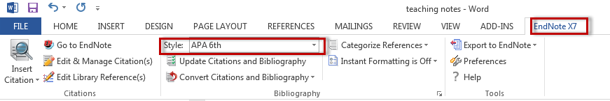

More on Adding References to your Endnote Library

PubMed

Option 1
- Check the boxes to the left of the citations you wish to move into EndNote.
- Click the Send to link near the top right of the screen.
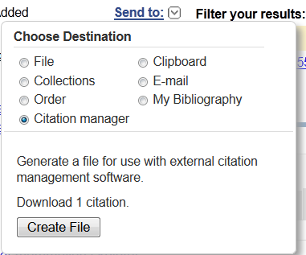
- Select Citation Manager
- Change the drop box to 200 (this way you ensure all your citations move over) and then click Create File.
- When prompted, select Open File.
- You may see a screen that says Windows Can’t Open this File. Don’t worry. Check the box that says Select a program from a list of installed programs and then select EndNote (NOTE: You will see an option to tell your computer to always use EndNote to open these types of files so it’s easier to do in the future).
- You will be prompted to Choose an Import Filter. Select PubMed (NLM) from the list and then click Choose. You citations will import into EndNote at this time.

Option 2 (use Option 2 when Option 1 does not work or you have more than 200 citations to import)
- Check the boxes to the left of the citations you wish to move into EndNote.
- Click the Send to link near the top right of the screen.
- Select File.
- Under Format select MEDLINE.
- Click the Create File button.
- Now, save the file to your desktop or another easy to remember location.
- Open EndNote and under the File menu, select Import. You’ll see a box like the one below.
- Click Choose File… to locate the text file you saved from PubMed.
- Make sure you sleet PubMed (NLM) after Import Option. Under Duplicates, it is recommended that you select Discard Duplicates from the drop-down menu. This will import all references except duplicates.
- Finally, click Import.
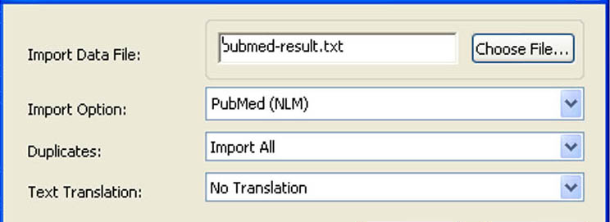

Web of Science
- Check the boxes next to the articles you wish to export to your EndNote library.
- Go to the Save to Endnote online menu found at the top and bottom of your search results page.
- Choose Save to EndNote desktop from the dropdown menu.
- The Send to EndNote dialog box will appear. Select Full Record from the drop down menu and click Send.
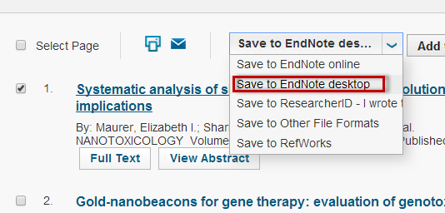

Scopus
- Check the boxes next to the articles you wish to export to your EndNote library.
- Click Export on the top of the search result page.
- Choose RIS format. Select the desired information to export from the drop-down menu. Click Export.
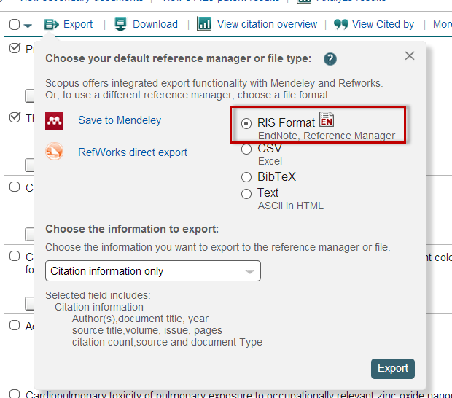

SciFinder
- Check the boxes next to the articles you wish to export to your EndNote library.
- Click Export on the right top of the search result page.
- In the op-up window, make sure citation export format (*.ris) is selected under Citation Manager. Leave the other settings as they are. Click Export.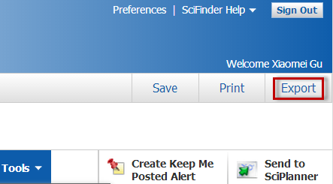

Adding References Manually
- In endnote, select References New Reference
- Select the appropriate Reference Type (ex. Journal article, book section, book, etc.) EndNote will mark fields needed for that type (editors’ names, chapter authors’ names, etc.).
- Fill in the appropriate fields. Author and page number fields should be entered as follows.
  - Authors must be entered one per line, so press Enter after each author’s name
    - Einstein, Howard G.
    - de Gaulle, Charles
    - Einstein, H G or Einstein, H.G. (not Einstein, HG)
    - Einstein, Albert, Jr.
    - American College of Physicians, (notice the comma at the end)
  - Page numbers can be entered in any of the following forms, with commas between non-consecutive ranges.
    - 1492-1497
    - 1492-7
    - 124-127, 130, 191-194

Adding PDF files
- Click on the File menu and select Import > File. The Import File dialog box will appear.
- Click on Choose and select the file that you wish to import.
- Under Import Option, select PDF from the drop-down menu.
- Click on Import when you have finished.
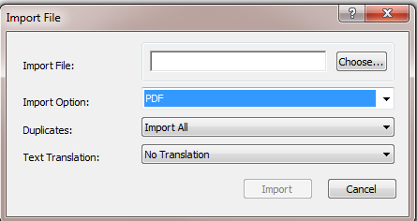

Adding multiple PDF files in a folder
- Click on the File menu and select Import > Folder. The Import Folder dialog box will appear.
- Click on Choose and select the folder that you wish to import.
- If you wish to include subfolders within the folder, select the box next to Include files in subfolders.
- If you want EndNote to create a separate group set for the main folder and groups within it for the subfolders, select the box next to Create a Group Set for this import.
- Under Import Option, select PDF from the drop-down menu.
- Click on Import when you have finished. All references within the folder and its subfolders will be imported into your EndNote library and a new Group Set and Groups will be created.

Adding References from RefWorks
- In RefWorks, select References > Export.
- Select All References in the drop-down menu to export all your references at once. Keep the format as Bibliographic Software. Click Export
- A new window or tab will open in your web browser, displaying your references. Save this file as a Plain Text file: TXT.
- In EndNote, select File > Import > File.... A window will open that allows you to select the RefWorks file you created in step three. Select Reference Manager (RIS) in Import Options, and Click "Import".
- Note that attachments will NOT be exported. Your folder structure will be lost, too. To keep it, export you folders one by one.

References from Mendeley
- In Mendeley, select File > Export.
- In the pop-up window, select RIS -Research Information Systems (*.ris) from the drop-down menu after Save as type:
- In EndNote, select File > Import > File.... A window will open that allows you to select the RefWorks file you created in step three. Select Reference Manager (RIS) in Import Options, and Click "Import".
- Note that attachments in will NOT be exported. Your folder structure will be lost, too. To keep it, export you folders one by one.

Advanced Tips

Defining Term Lists for an Existing Library
If you did not define your Journals term list when you created your library, then your term list has been created automatically as you enter new references into your library (whether by importing or manually entering them). To ensure consistency and accuracy, we recommend that you discard your existing Journal term list and import Journal term lists from EndNote.
- Under EndNote’s Tools menu, select Define Term Lists.
- In the Lists tab, highlight Journals. Then select the Terms tab. Highlight all the terms by selecting Ctrl + A on your keyboard. Click the Delete Term button.
- Now, you are ready to import term lists. Return to the Lists tab. Click the Import List... button. Navigate to the folder where EndNote is installed (usually C:\Program Files\EndNote) and open the Term Lists folder.
- Select the term list you wish to import. For the health sciences, we recommend that you import the Medical and Humanities term lists. Click Open. After the terms are installed, click OK. Repeat for each term list that you wish to add. Click Close when you have finished.

Organizing your EndNote library
- We recommend you keep your references in one EndNote library and use the Groups feature to you to organize your references. One reference can be assigned into multiple groups.
- To create a Group, select Create Group from the Groups menu on the top of your EndNote screen.
- To add a reference to a group, right click on the reference, select Add References to and then your desired group.

Moving your EndNote Library to another Computer/Backing up EndNote Library
- Select Select > Compressed Library (.enlx) and save (or email) your file.
- To pen this file, simply double-click it (note EndNote has to be installed on your computer).
Note: This allows you to back up a copy of your library, move your library to another computer, or send someone else a copy of your library. If you wish to access your library from multiple computers, do this instead: move your Endnote Library in a shared drive when you can access it through multiple computers. Remember that you will need to move two separate parts, which are located in the same folder. These two parts are your EndNote Library, which have the extension .enl, and a folder with the same name as your EndNote Library, but with a .Data extension.
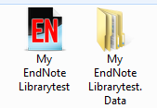

Modify, Add or Delete Formatted Citations
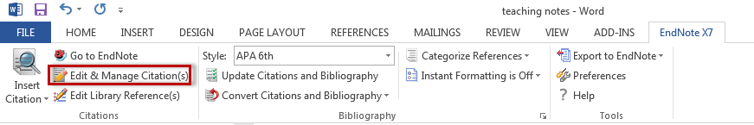

Find Duplicates
- Prior to inserting citations, we recommend that you find duplicate references within your EndNote library.
- To find duplicate references, select References > Find Duplicates.
- If you have duplicate references in your library, the Find Duplicates dialog box will appear.

Change Citation Style (bibliography style)
