Evidence Based Searching for FCP IV – January 13, 2014
Learning Objectives
- Locate the FCP IV LibGuide/Subject Guide
- Name a resource that will assist with prepping for the USMLE
- Select appropriate resources with information on differential diagnosis
- Utilize several databases to locate evidence based diagnostic test information
- List three ways to find higher quality diagnostic information in PubMed
- Use MyNCBI to quickly filter searches (You should have set up your filters before class)

General Resources
- Foundations of Clinical Practice IV Subject Guide (http://guides.lib.uiowa.edu/fcp4)
  - This is a great place to start. The resources have been specially selected for your needs.
    - List of textbooks for FCP IV with links when an electronic version is available
    - Physical Examination – don’t forget about the Simulation Center!
    - USMLE resources
    - Differential Diagnosis

- Evidence Based Practice Subject Guide (http://guides.lib.uiowa.edu/ebp)

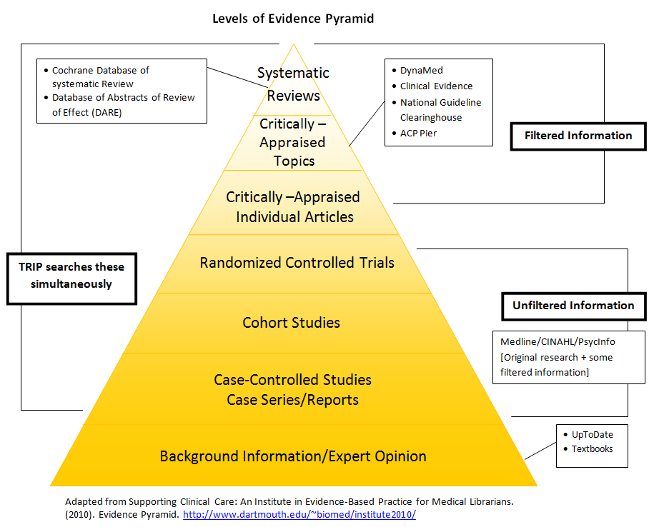
Publication Types by Question Type: Different study types are suited to different questions. For example:

Most Clinical Questions: Meta-analyses, systematic reviews

Diagnosis:
Prospective, blind controlled trial compared to gold standard (often looking for a cohort)

Test Characteristics
- Sensitivity: Sn(out) – tests with a high sensitivity can be used to rule a disease out.
- Specificity: Sp(in) – tests with a high specificity can be used to rule a disease in.
- Likelihood Ratio – indicates the extent to which a given diagnostic test result will increase or decrease the pretest probability of the target disorder.
  - LR+ = sensitivity / (1-specificity)
  - LR- = (1-sensitivity) / specificity
- Pre-test and Post- Test Probability: Pre-test probability is based on your expertise and whether you think a patient has the disease. You use this with your likelihood ratio and the nomogram to determine post-test probability of disease.

Resources to Remember
Critically-Appraised Topics (Evidence Syntheses):

  - DynaMed: provides evidence based summaries with evidence ratings for a wide range of diseases and drugs.
  - ACP Smart Medicine: provides evidence based summaries of various diseases, treatments, and procedures. All recommendations receive evidence ratings and are referenced.
Unfiltered Resources [Searching the primary literature] Evidence is not always available via filtered resource, either because the research is too new or the question is very specific. In those cases, you may want to search a database like PubMed.
Below are a few tips to assist you with locating evidence for supporting diagnostic decision making in PubMed.
  - Click on "clinical queries". This specialized search is intended for clinicians and has built-in search "filters."
  - limit to publication types such as systematic reviews, randomized controlled trials, etc.
  - Use MeSH – This will give you more focused results. There are even terms for “Differential Diagnosis” and “Prognosis”
  - Use subheadings – There’s a subheading for “diagnosis” that can be used for just about any disease MeSH term.
Background Information/Expert Opinion (Not evidence based!)
- Books – You can find these using InfoHawk or SmartSearch
- UpToDate – This cannot be a source for your EBM assignments, but it can still be used for background information.

Personal Librarian: Amy Blevins, MALS
amy-blevins@uiowa.edu or (319) 335-7636

