CINAHL
CINAHL covers the nursing and allied health literature, and can be useful for any search on a health sciences topic.
Accessing the Database
- Instructions on how to access CINAHL for FREE can be found on the Free Clinical Research & Patient Wellness Resources LibGuide at http://guides.lib.uiowa.edu/crpw
Searching via Subject Terms (More structured search meant to yield higher quality citations)
- Break your search down into simple concepts. For example, if you want articles on the use of pet therapy for people with mental disorders, search for pet therapy first, then mental disorders. You can combine searches later.
- Make sure the to click on the CINAHL Headings , and then type one concept into the search box and click on the button that says “Browse.”
- Check the box to the left of the most appropriate term. Notice that you will now see options for subheadings as well as the definition of the term if available. Subheadings can help you focus your search.
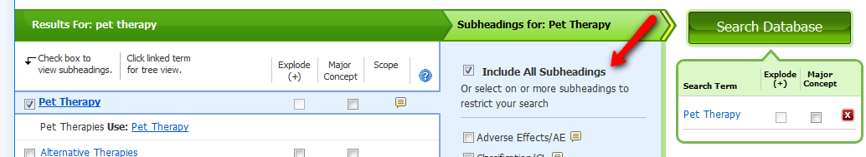
- Once you have selected your subheadings, click the large green “Search Database” button. (NOTE: “Explode” will make your search more comprehensive and can only be checked if the box is shadowed. Use “Major Concept” only if you have already run the search and come up with too many results).
- The database will run your search and present you with results. Clear the search box.
- Repeat steps 2-4 for each additional concept.
- Click the link for “Search History/Alerts. It is located below the search boxes.
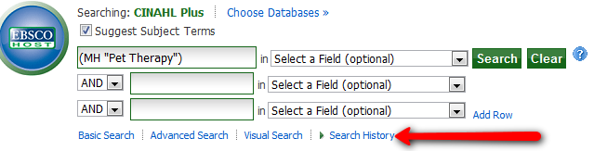
- Clear your search box of all text. Now, you want to combine your search sets, so, check the boxes to the left of the searches you already ran, and then click on the little button that says “Search with AND” at the top of the Search History box.
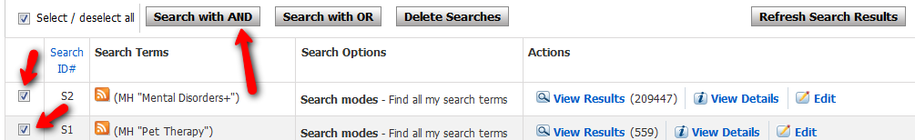
- You will see a new search to your search history box. To view the results, click on the link that says “View Results.”

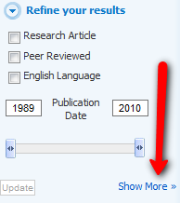
Refining Your Search
- If you need to find information on a certain age group, from a certain time period (e.g. the last ten years) or of a certain publication type (like peer reviewed), you will want to limit your results. To do this, click on the link that says “Show More” located in the “Refine Your Results” box to the left of the retrieved citations.
- Now, select the limits that are appropriate to your search. Keep in mind that you may select more than one, but the more you choose, the fewer results you will get. You might want to limit to only a few options at a time.
- When you have selected your limits, go to the top or bottom of the new screen that appears and click on the “Search” button. Once again, you will see a new search with the option to “View Results.”

Managing Results
- If you want to print or email citations, you can do so by clicking on the little folders near the bottom of the citations.
- Once you have selected all the appropriate citations, click on the folder icon at the top right of the screen. Now, you will see links for emailing or printing citations.

Finding Full Text
- Click the title of an article to see more information, including options for full text access, abstracts (when available), and subject terms.

